Module 4 Assignment # 2 Instructions
After reading the chapters in this module, students will design the logic for an application and submit a partially completed Java program.
The BMC Parts Company needs a program that will read the inventory.txt file and create an inventory report based on the data in the file. The inventory.txt file contains the part number, opening balance, number of items sold, and the minimum stock required. The output file, inventoryNeeded.txt, will contain the part number, current balance and the amount that is necessary to bring the inventory to the minimum level.
In this assignment, students will design the logic for the program that reads the input file and creates the output file. Files provided include inventory.txt and the partially completed program inventoryNeeded.java. The program file provided includes the necessary variable declarations and input and output file statements. You need to write the part of the program that reads the input file, calculates the current balance and amount required to bring the inventory to the minimum level. Then output the part number, current balance and the amount needed to the output file.
In this assignment, students will submit both the .java and the .class files for the completed program along with the output file created from the program execution, and the pseudocode. The files will be submitted by the posted due date using the appropriate dropbox.
The pseudocode must be submitted as a Microsoft Word compatible file. Examples of Word compatible documents are those with a .doc, .docx, or .rtf file extension. If there is a question about the format, consult with your instructor before submitting your assignment.
inventory.txt file contains:
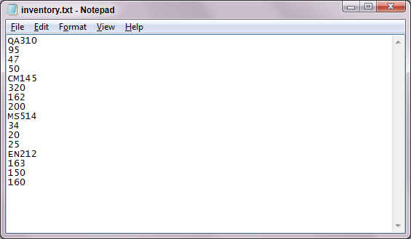
Output file – inventoryNeeded.txt should look like this
